**Exercise**

**Building Multiple Configurations by using Templates**

**Exercise - Build multiple configurations by using templates**

* 11 minutes

In the previous exercises, you implemented a pipeline that builds the *Space Game* web site. You started with a script that performs each build action and mapped each action to its corresponding pipeline task. The output of the pipeline is a *.zip* file that contains the compiled web application.

In this exercise, you use a template to define build tasks that can build any configuration defined in the project file. Templates enable you to define your logic one time and then reuse it several times. Templates combine the content of multiple YAML files into a single pipeline.

Let's begin by checking in with Mara and Amita.

**The demo**

Mara, excited to share her results, tracks down Amita to show her the build pipeline.

**Amita:** I'm impressed you got this working so quickly! In fact, I was just coming to see you because I got an email telling me the build was ready. Thank you! But I see that the pipeline builds only the Release configuration. We also use Debug builds so we can capture additional information if the application crashes. Can we add that?

**Mara:** Absolutely. I forgot to consider Debug builds when I set this up. How about we sit down together and add it?

**Amita:** You showed me the YAML file that defines the build steps, but I'm not sure I would know how to modify it.

**Mara:** That's OK. You can watch while I type. We can think through it together.

**How might you define both build configurations?**

Consider the following tasks that build and publish the *Space Game* web project's Release configuration. (Don't add this code to your *azure-pipelines.yml* file.)

yml

- task: DotNetCoreCLI@2

displayName: 'Build the project - Release'

inputs:

command: 'build'

arguments: '--no-restore --configuration Release'

projects: '**/*.csproj'

- task: DotNetCoreCLI@2

displayName: 'Publish the project - Release'

inputs:

command: 'publish'

projects: '**/*.csproj'

publishWebProjects: false

arguments: '--no-build --configuration Release --output $(Build.ArtifactStagingDirectory)/Release'

zipAfterPublish: true

To build the Debug configuration, you might repeat these two tasks, but replace Release with Debug.

Doing so would give you the result you're looking for, but what happens when your build becomes more complex or your requirements change? You'd need to manually locate and change both variations of each build task. After you added the additional build requirements, you'd also need to create two tasks, one for the Debug configuration and one for Release, to satisfy those requirements.

A better solution is to use a template.

**What are templates?**

A *template* enables you to define common build tasks one time and reuse those tasks multiple times.

You call a template from the parent pipeline as a build step. You can pass parameters into a template from the parent pipeline.

Mara can define tasks to build and publish the application as a template and then apply that template to each configuration she needs.

**Define the template**

Remember that a template enables you to define common build tasks one time and reuse those tasks multiple times. You call a template from its parent template as a build step and pass parameters into a template from the parent pipeline.

You'll now create a template that can build any configuration that's defined in the project file.

1. From the Visual Studio Code integrated console, create a *templates* directory at the root of your project:

**Bash**

**mkdir templates**

In practice, you can put a template file in any location. You don't need to put them in the *templates* directory.

1. In Visual Studio Code, select **File > New File**. Then select **File > Save** to save the blank file as *build.yml* in your project's *templates* directory. (For example, *~/mslearn-tailspin-spacegame-web/templates*.)

**Important**

As before, on Windows, be sure to select **YAML** in the **Save as type** list.

1. In Visual Studio Code, add this code to *build.yml*:

**yml**

parameters:

buildConfiguration: 'Release'

steps:

- task: DotNetCoreCLI@2

displayName: 'Build the project - ${{ parameters.buildConfiguration }}'

inputs:

command: 'build'

arguments: '--no-restore --configuration ${{ parameters.buildConfiguration }}'

projects: '**/*.csproj'

- task: DotNetCoreCLI@2

displayName: 'Publish the project - ${{ parameters.buildConfiguration }}'

inputs:

command: 'publish'

projects: '**/*.csproj'

publishWebProjects: false

arguments: '--no-build --configuration ${{ parameters.buildConfiguration }} --output $(Build.ArtifactStagingDirectory)/${{ parameters.buildConfiguration }}'

zipAfterPublish: true

These tasks look like the ones you defined earlier to build and publish the application. But in a template you work with input parameters differently than you work with normal variables. Here are two differences:

* + In a template file, you use the parameters section instead of variables to define inputs.
  + In a template file, you use ${{ }} syntax instead of $() to read a parameter's value. When you read a parameter's value, you include the parameters section in its name. For example, ${{ parameters.buildConfiguration }}.

**Call the template from the pipeline**

You'll now call the template that you just built from the pipeline. You'll do so one time for the Debug configuration and then repeat the process for the Release configuration.

1. In Visual Studio Code, modify *azure-pipelines.yml* as you see here:

**Yml**

trigger:

- '*'

pool:

vmImage: 'ubuntu-18.04'

demands:

- npm

variables:

buildConfiguration: 'Release'

wwwrootDir: 'Tailspin.SpaceGame.Web/wwwroot'

dotnetSdkVersion: '3.1.300'

steps:

- task: UseDotNet@2

displayName: 'Use .NET Core SDK $(dotnetSdkVersion)'

inputs:

version: '$(dotnetSdkVersion)'

- task: Npm@1

displayName: 'Run npm install'

inputs:

verbose: false

- script: './node_modules/.bin/node-sass $(wwwrootDir) --output $(wwwrootDir)'

displayName: 'Compile Sass assets'

- task: gulp@1

displayName: 'Run gulp tasks'

- script: 'echo "$(Build.DefinitionName), $(Build.BuildId), $(Build.BuildNumber)" > buildinfo.txt'

displayName: 'Write build info'

workingDirectory: $(wwwrootDir)

- task: DotNetCoreCLI@2

displayName: 'Restore project dependencies'

inputs:

command: 'restore'

projects: '**/*.csproj'

- template: templates/build.yml

parameters:

buildConfiguration: 'Debug'

- template: templates/build.yml

parameters:

buildConfiguration: 'Release'

- task: PublishBuildArtifacts@1

displayName: 'Publish Artifact: drop'

condition: succeeded()

This file looks like the original, except that it replaces the build and publish tasks with calls to the template that performs the same tasks.

You see that the template is called one time for each configuration. Each template task uses the parameters argument to pass the configuration name to the template.

**Run the pipeline**

You'll now push your changes to GitHub and see the pipeline run.

1. From the integrated terminal, add *azure-pipelines.yml* and **templates/build.yml** to the index, commit the changes, and push the changes up to GitHub:

**Bash**

**git add azure-pipelines.yml templates/build.yml**

**git commit -m** "Support build configurations"

**git push origin build-pipeline**

1. Navigate to Azure Pipelines. You will see the recently run pipeline as below

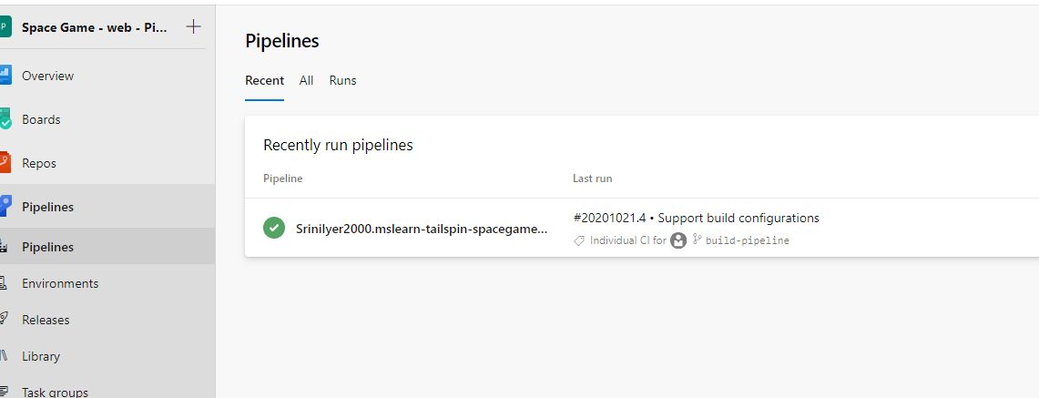

1. From Azure Pipelines, trace the build through each of the steps, as you did earlier.

As the pipeline runs, you see that the process expands the tasks within the template. The tasks that build and publish the project are run two times, once for each build configuration:

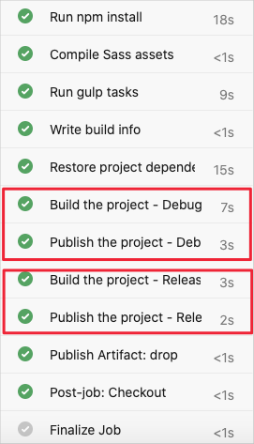

1. When the build completes, go back to the summary page and select the published artifact as you did before.

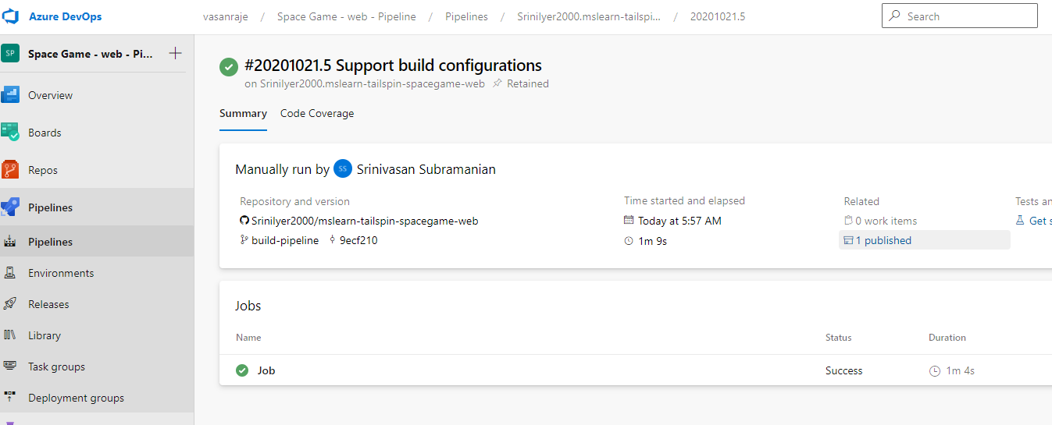

1. Expand the drop folder.

You see that the pipeline produces a *.zip* file for both the Debug configuration and the Release configuration.

The packaged application for Debug and Release configurations in the Artifacts explorer

**Merge the branch into master**

At this point, you have a working build pipeline that accomplishes everything Mara needs for right now.

In practice, you'd submit a *pull request* that merges your build-pipeline branch into the master branch.

We'll skip that step for now. In the next module, you'll learn some ways to collaborate with your team on GitHub, including how to submit, review, and merge pull requests.